Cultus CJR Project

Project Title
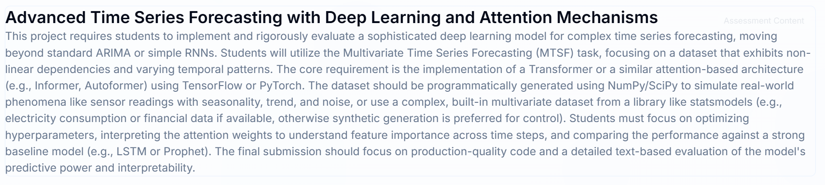
Project Explanation
The project is an assignment focused on developing advanced multivariate time series forecasting models using deep learning techniques beyond traditional methods like ARIMA or simple RNNs.
Goal: To implement and evaluate a sophisticated deep learning model, specifically a Transformer or a related attention-based architecture (e.g., Informer, Auto former), for complex forecasting tasks.
Key Requirements:
- Use a multivariate dataset that shows non-linear dependencies.
- Implement the model using either TensorFlow or PyTorch.
- Focus on hyperparameter optimization and interpreting the attention weights to understand how the model uses different time steps to make predictions.
- Compare the performance against a strong baseline model, such as an LSTM or Prophet.
- Deliver production-quality code and a detailed evaluation report.
Simple RNNs (Recurrent Neural Networks)
Simple RNNs are a type of deep learning model specifically designed to handle sequential and temporal data. Unlike traditional neural networks which treat each input independently, RNNs have a looping mechanism or internal memory that allows them to use information from previous time steps to inform the current prediction.
- Sequential Data Handling: RNNs process data in sequence, maintaining a hidden state that carries information forward from one time step to the next.
- Non-linear Capability: They are capable of capturing complex, non-linear dependencies and patterns in data, which is where traditional linear models like ARIMA fall short.
- Limitations: Simple RNNs suffer from the "vanishing gradient problem," which makes it difficult for them to learn and remember long-term dependencies in very long sequences of data. This limitation led to the development of more advanced architectures like LSTMs and the Transformers mentioned in the project description.
Summary of RNN
Feature | Simple RNN
Model Type | Deep learning, non-linear
Data Requirement | Can handle both stationary and non-stationary data
Complexity | More complex, less interpretable
Data Volume | Generally requires large datasets for effective training
Long-Term Dependencies | Struggles due to vanishing gradients

Introduction to LSTM Neural Networks
LSTM (Long Short-Term Memory) is a special type of recurrent neural network (RNN) designed to learn and remember long-term dependencies in sequential data. It solves the problem of traditional RNNs that struggle with the vanishing gradient problem, making it highly effective for tasks like language modelling, speech recognition, and time-series forecasting.
Key Points About LSTM
- Origin: Introduced by Hochreiter and Schmidhuber in 1997.
- Core Idea: Unlike standard RNNs, LSTMs use a memory cell that can store information for long periods.
- Gates Mechanism:
  - Input Gate: Controls how much new information enters the cell.
  - Forget Gate: Decides what information to discard.
  - Output Gate: Determines what information is passed to the next step.
- Advantage: Handles long sequences without losing context, unlike traditional RNNs that forget earlier inputs.
- Applications:
- Natural Language Processing (NLP): machine translation, text generation.
- Speech recognition.
- Time-series prediction (e.g., stock prices, weather forecasting).
- Video analysis.
Dataset and pre-processing
You can run this on the UCI Electricity Load Diagrams dataset (multivariate, hourly consumption). If the CSV isn’t available locally, the synthetic generator will create a realistic multivariate dataset with trend, seasonality, and noise.
TensorFlow Transformer encoder model for multivariate time series forecasting
This model uses learned positional embeddings, Multi Head Attention, residual connections, and a feed-forward network. It predicts the full horizon in one shot. It also returns attention scores so you can interpret which timesteps were most influential.
Training and evaluation
We train with MAE loss (robust for scale differences) and report MAE/RMSE. For multivariate data, we compute metrics over all features.
Interpreting attention weights
Build an analysis model that shares the same architecture to return attention scores. We’ll copy the trained weights to the attention-enabled model and visualize which timesteps the encoder focused on.
LSTM baseline for comparison
A compact baseline using stacked LSTMs. Train and evaluate with the same datasets.
References
Real-Time Dataset Recommendation
You can use the Electricity Load Diagrams 2011–2014 dataset from the UCI repository. It contains electricity consumption data from 370 clients over time, making it ideal for multivariate forecasting.
- Source: UCI Electricity Load Dataset
- Features: Hourly electricity usage, multiple clients (multivariate), seasonal and trend patterns

